# **Political juggernauts : A Quantitative Analysis of Candidates in the 2019 Lok Sabha Elections**

1.Introduction

This project, titled **"Political Juggernauts: A Quantitative Analysis of Candidates in** t**he 2019 Lok Shaba Elections,”** Commission of India recognises parties as either national or state parties based on their performance in previous elections. Delhi and Haryana have a high number of candidates contesting from parties that have not been recognised as either national or state parties. After Telangana Tamil Nadu has the highest average of independent candidates contesting in this election. On average, of the candidates in each constituency in Tamil Nadu, two-thirds are contesting as independent candidates.

* 1. **Overview**

**1.1.1 The application of quantitative**

Quantitative analysis is used by governments, investors, and businesses (in areas such as finance, project management, production planning, and marketing) to study a certain situation or event, measure it, predict outcomes, and thus help in decision-making

***1.1.2 Methodology:***

* Political methodology is a rapidly changing and fascinating subfield of political science.
* From text analysis to scaling models to network models to machine learning methods, political science sits at the forefront of applied statistical research on several fronts.
* This course will cover the foundations necessary to work at the frontier of political methodology, and then we will move through selected topics.

**2. PROBLEM DEFINITION & DESIGN THINKING**

**2.1 Empathy Map**

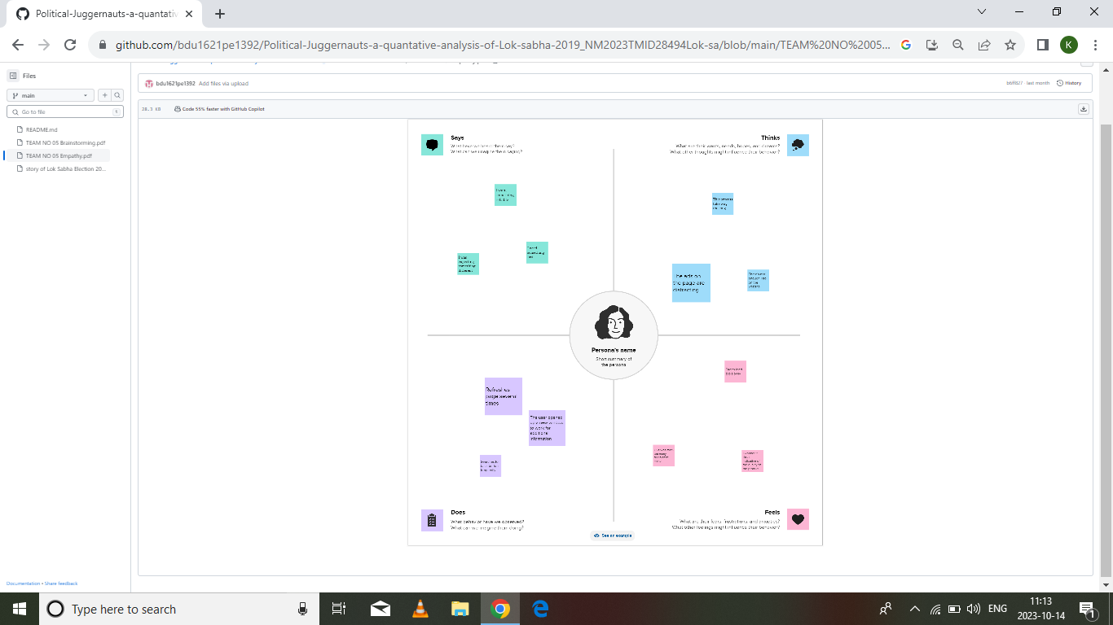

Empathy Map

# 2.2 Ideation & Brainstorming Map

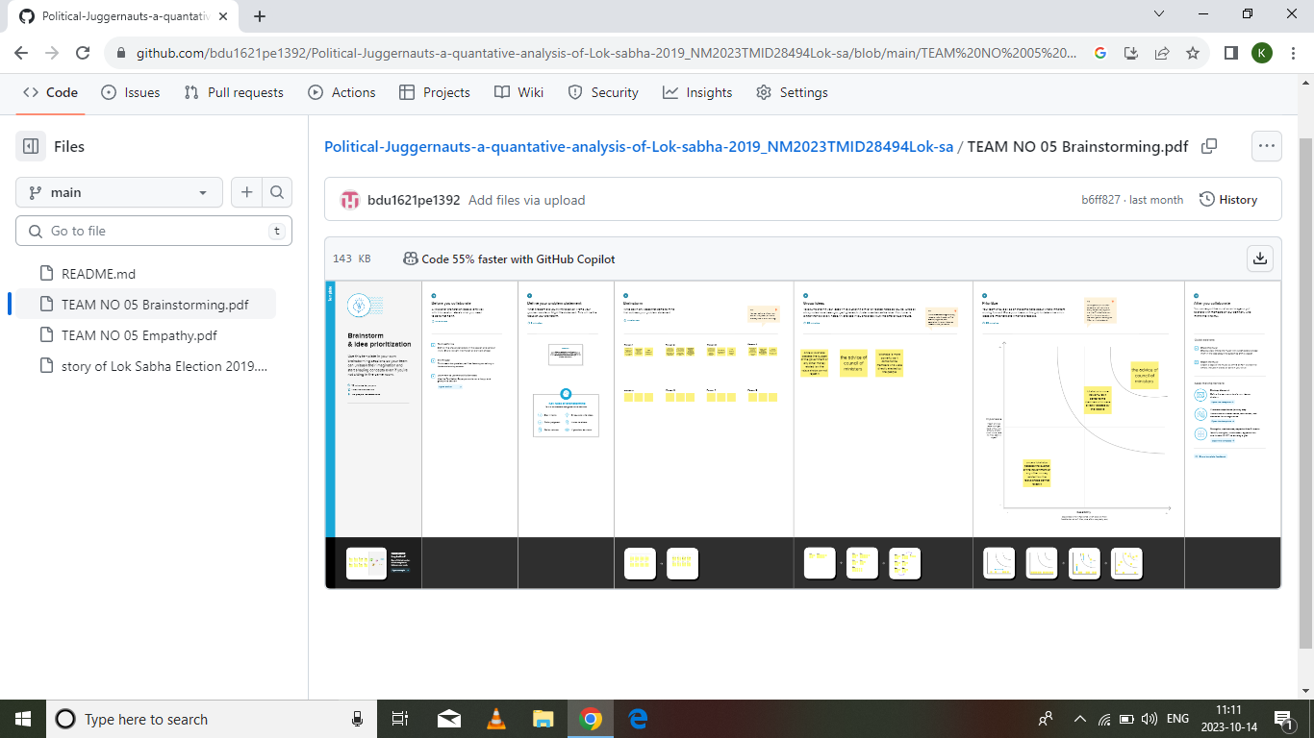

**3. RESULT**

The Lok Sabha is the lower house of parliament of India. The members of the lok sabha are elected by the universal adult suffrage. The tenure of the lok sabha is 5 years. In practice, the Lok Sabha is more powerful than the Rajya Sabha.

**3.1 Visualizations**

**State inPolitical Juggernauts**

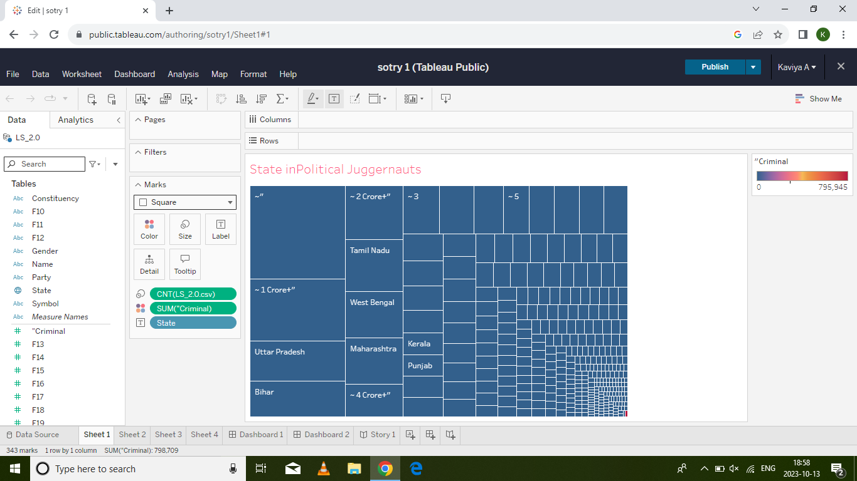

***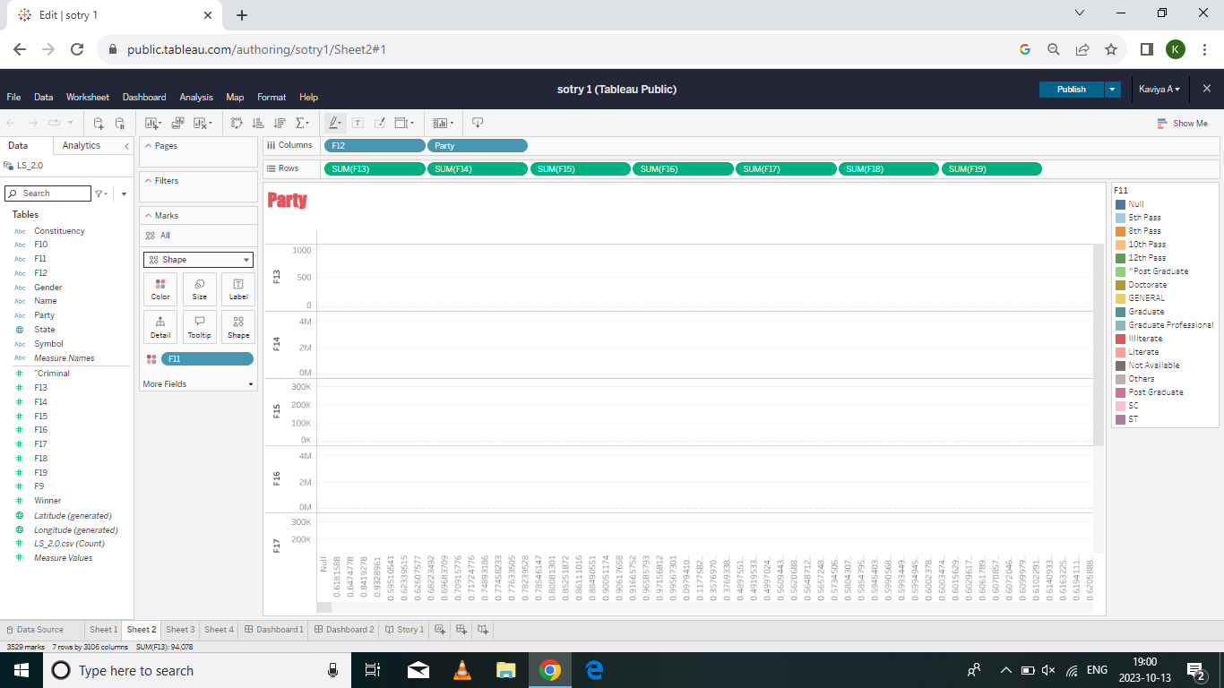*Party**

**Horizontl Bars For Political**

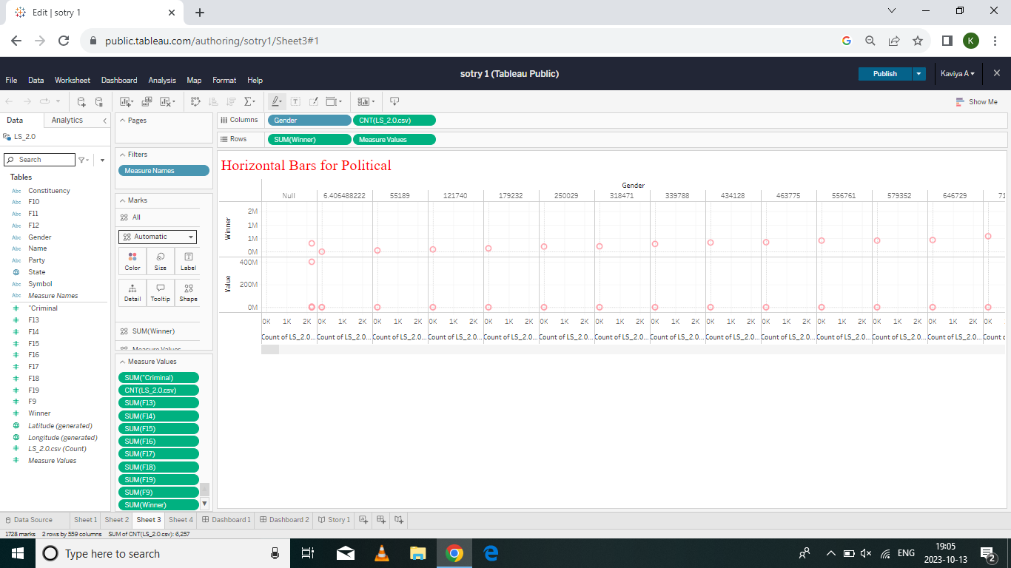

***Symbol for Lok Sabha Election***

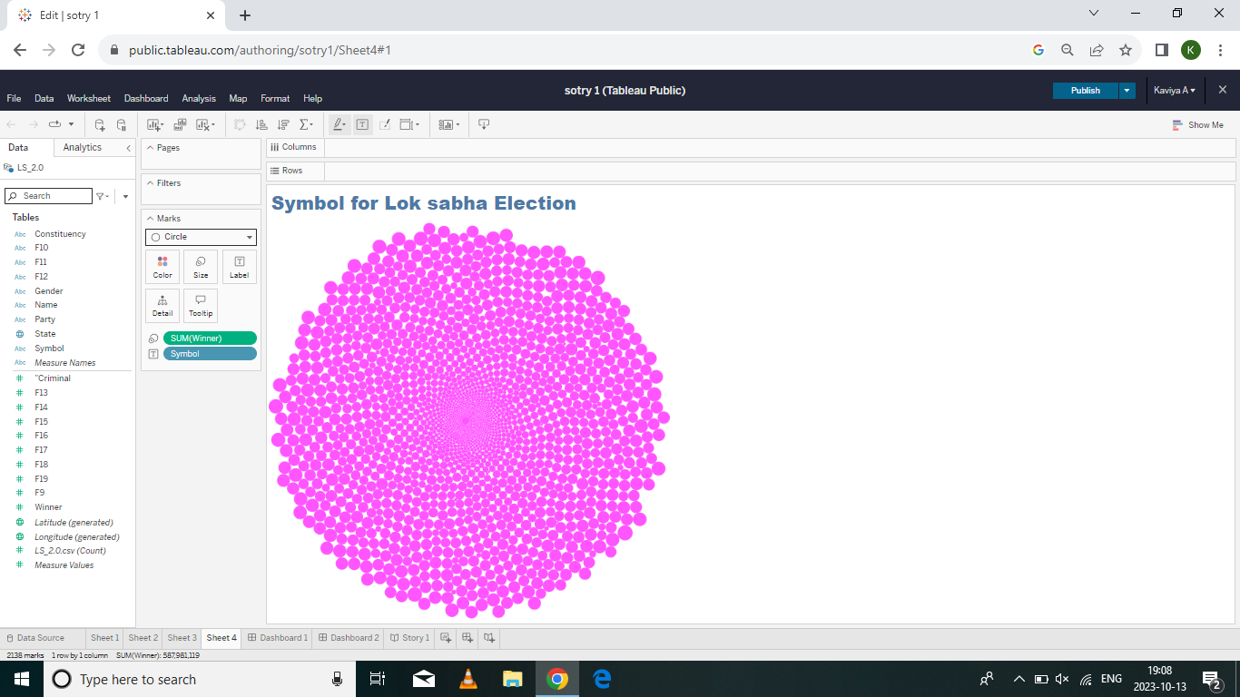

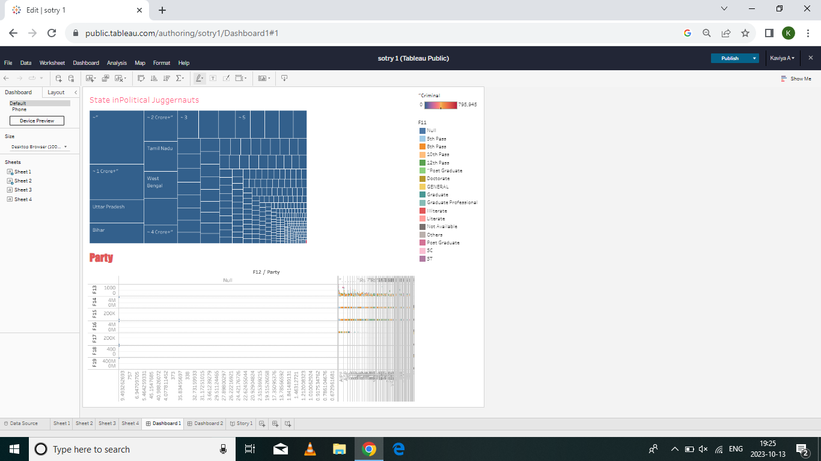***3.2 Dashboard***

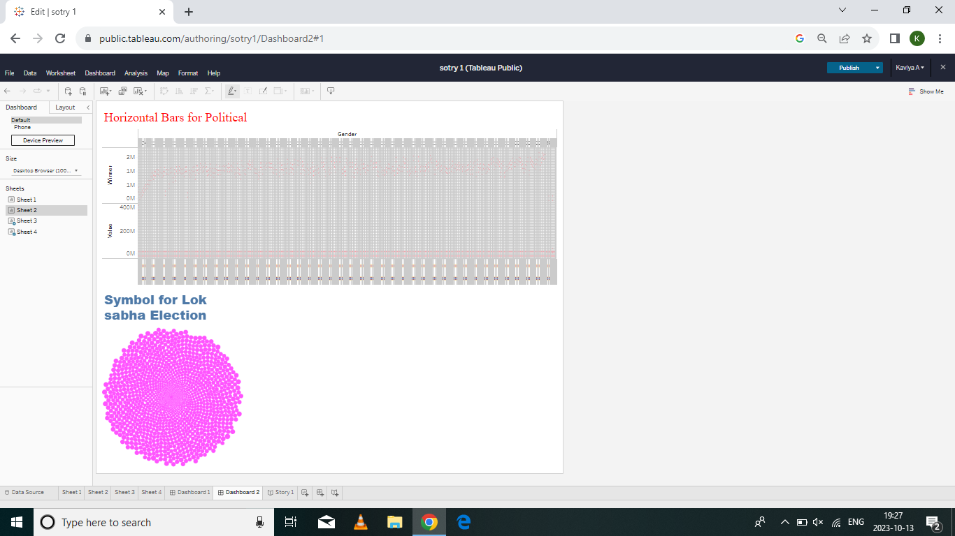

***3.3 Story***

***3.3 Story***

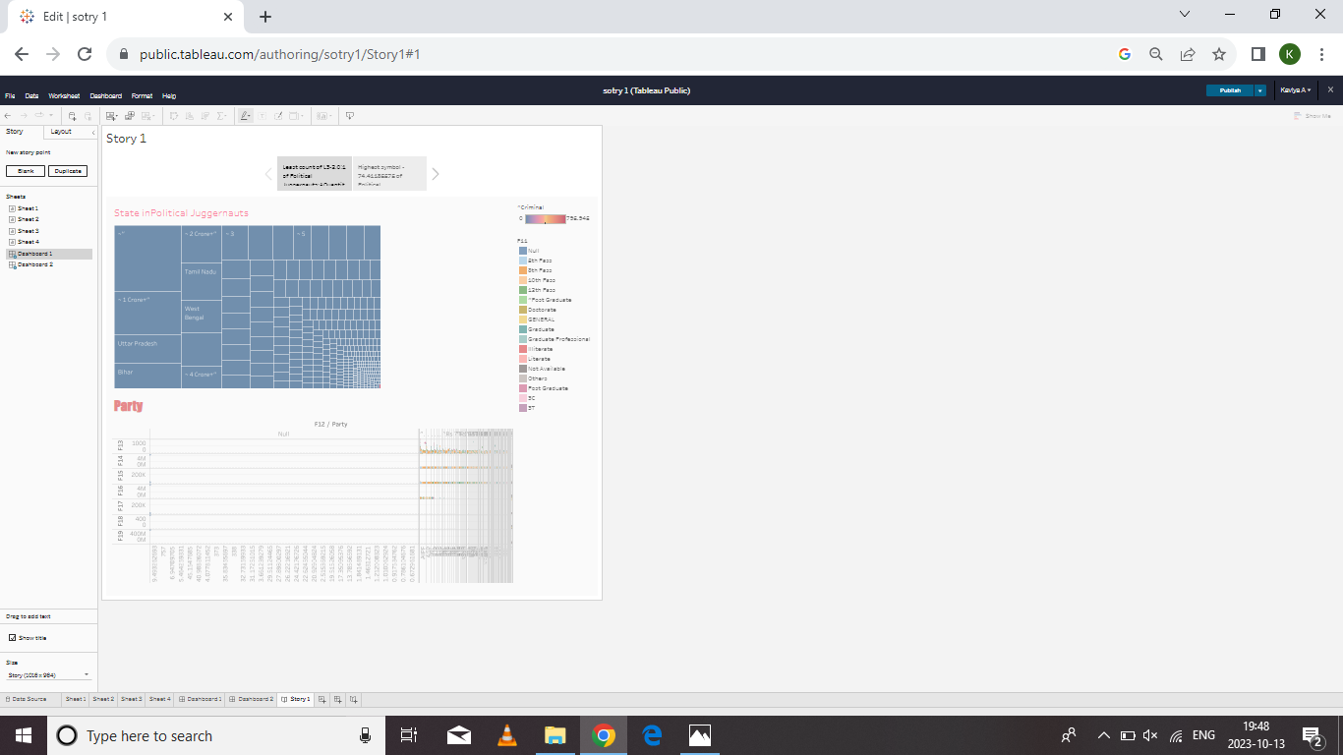

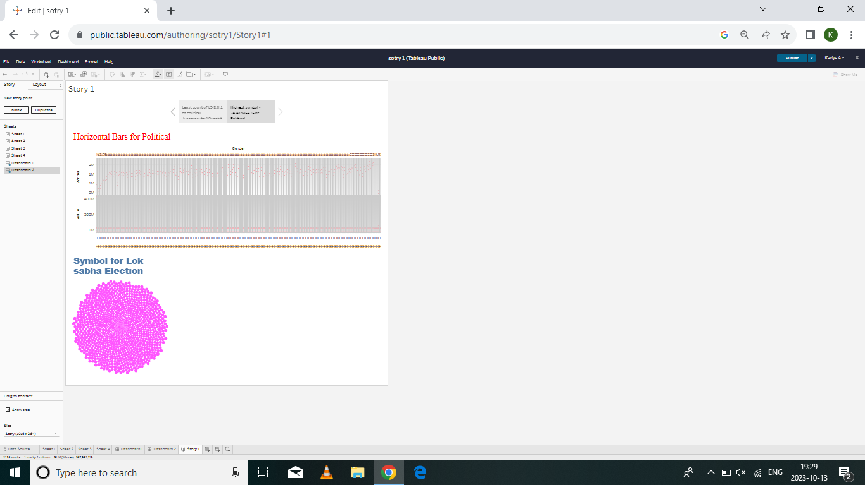

**3.4 Performance Testing**

* **Amount of Data Rendered to Tableau:**

The volume of data presented in Tableau is directly influenced by the dimensions of the dataset.

**Utilization of Data Filters:**



**No of Visualizations/ Graphs:**

* State in Political Juggernauts
* Party
* Horizontal Bar for Political
* Symbol for Lok Shaba Election

**4. ADVANTAGES & DISADVANTAGES**

**4.1 Advantages**

* These are the following advantages of the Lok Sabha:-
* It helps in proper functioning of democracy through the system of checks and balances.
* No confidence motion can only be introduced and passed in the Lok Sabha. So, it controls the despotism of the government.
* Money bills can be only introduced in the Lok Sabha. The Rajya Sabha can only suggest a money bill.
* There is the requirement of the majority in the Lok Sabha to form the government.
* One should complete 25 years of age to be the member of the Lok Sabha.
* People of India directly choose the member of Lok Sabha so this house is a direct representation of people.
* Here people’s representatives represent various problems of people from all over the country.

**4.2 Disadvantages**

* Ack of representation: The Lok Sabha is based on a first-past-the-post electoral system, which can result in a lack of representation for minority parties and groups.
* Limited accountability: Members of the Lok Sabha are not always held accountable for their actions, as they are protected by parliamentary immunity.
* Political instability: The Lok Sabha can be subject to frequent disruptions and disruptions, which can lead to political instability and a lack of progress on important issues.
* Limited powers: The Lok Sabha has limited powers compared to the Rajya Sabha (upper house of the Indian Parliament), which can make it difficult for the Lok Sabha to effectively legislate and govern.

**5. APPLICATIONS**

The application of " Political Lok Shaba Election”

* They must be a citizen of India and should pledge before the Election Commission of India an oath or declaration as per the form set out for the principle of the Indian Constitution.
* They should not be declared criminal, i.e. they must not be a convict, a verified debtor, or otherwise debarred by law; and
* They must contain their name in the electoral rolls in any country area.
* Motions of No-Confidence against the government can only be introduced and passed in the Lok Sabha.
* Money Bills can only be introduced in the Lok Sabha.
* In case of a deadlock between the two Houses over an ordinary bill, the will of the Lok Sabha normally prevails.

**6. CONCLUSION**

The "“Political Juggernauts :A Quantitative Analysis of Candidates in the 2019 Lok Shaba Elections,”project successfully utilized Tableau to analyze spending behavior, identify opportunities for growth, and provide actionable insights for strategic decision-making. The findings and recommendations outlined in this report serve as a valuable resource for stakeholders aiming to enhance market competitiveness and drive sustainable business growth.

Lok Sabha and Rajya Sabha are two of India’s bicameralParliament House houses. Lok Sabha is the lower chamber (house of the people) of Parliament, and Rajya Sabha is called the upper chamber. The members of the Lok Sabha are chosen via General Elections, contested based on the universal adult suffrage.

This project underscores the importance of leveraging advanced analytics tools like Tableau to unlock the full potential of data, transforming it into a strategic asset for organizations in a rapidly evolving market landscape.

**7. FUTURE SCOPE**

The future scope of “Political Juggernauts :A Quantitative Analysis of Candidates in the 2019 Lok Shaba Elections,” using Tableau is likely to be characterized by advancements in AI, real-time analytics, data security, and improved user experiences. As the field of data visualization and analytics continues to evolve, Tableau is poised to play a crucial role in empowering organizations with actionable insights for strategic decision-making.

**8. APPENDIX**

A. **Source Code:**